Unit 3: Test 3 Name: _________________________

Redox chemistry/galvanic cells Mark: ______/50

SECTION A – Multiple-choice questions

Instructions for Section A
Answer all questions.
Choose the response that is correct for the question.
A correct answer scores 1, an incorrect answer scores 0.
Marks are not deducted for incorrect answers.
If more than one answer is completed for any question, no mark will be given.

Question 1
Vanadium is an example of a transition metal that has more than one oxidation state.
The following ions or compounds containing vanadium are known to exist;

V₂O₅ VO₂⁺ VO²⁺ VCl₃ VCl₂

The oxidation number(s) of vanadium in the above compounds is
A. -1 and -2
B. +2 and +3 only
C. +3 and +5 only
D. +2, +3, +4 and +5

Use the following information to answer questions 2 and 3
The equation for the reaction occurring in zinc, silver oxide button cells is

Zn(s) + Ag₂O(s) + H₂O(l) 2Ag(s) + Zn(OH)₂(s)

Question 2
In this cell
A. electrons will flow from the silver oxide to the zinc.
B. zinc metal is reduced and silver oxide oxidised.
C. zinc metal is the reductant and silver ions are the oxidant.
D. the zinc metal will be the positive electrode and silver the negative.

Question 3
In this cell, the reaction
A. will produce twice the mass of silver as zinc.
B. will see the same number of zinc atoms react as silver ions.
C. will cause the mass of the cell to drop steadily as zinc metals corrodes away.
D. will produce silver atoms at twice the rate zinc atoms react.

Question 4
The half equation Sn⁴⁺(aq) + 2e ⇄ Sn²⁺(aq) is listed on your electrochemical series. The half-cell required for this reaction could have a
A. Sn(NO₃)₂ solution and a platinum electrode
B. Sn(NO₃)₄ solution, a Sn(NO₃)₂ solution and a platinum electrode
C. Sn(NO₃)₄ solution, a Sn(NO₃)₂ solution and a Sn electrode
D. Sn(NO₃)₄ solution with a Sn electrode

Question 5
If a cell is constructed with the overall equation

2Cr(s) + 3CoCl₂(aq) 2CrCl₃(aq) + 3Co(s)

A. the mass of chromium reacting will be 2/3 times the mass of cobalt forming
B. the mass of chromium reacting will be 3/2 times the mass of cobalt forming
C. the number of mole of chromium reacting will be 3/2 times the mole of cobalt forming
D. the number of mole of chromium reacting will be 2/3 times the mole of cobalt forming

Use the following table of half equations and potentials to answer questions 6 and 7

Au³⁺(aq) + 3e⁻ ⇄ Au(s) 1.50 V
Ce⁴⁺(aq) + e⁻ ⇄ Ce³⁺(aq) 1.74 V
Pb²⁺(aq) + 2e⁻ ⇄ Pb(s) -0.13 V
Ti²⁺(aq) + 2e⁻ ⇄ Ti(s) -1.63

Question 6
The strongest oxidant and strongest reductant on this list are, respectively
A. Ce⁴⁺ and Ti
B. Ce³⁺ and Ti²⁺
C. Au³⁺ and Ti
D. Au and Ti²⁺

Question 7
A spontaneous reaction will occur when
A. Gold is dropped into Pb(NO₃)₂ solution
B. Gold is dropped into Ce(NO₃)₄ solution
C. Lead is dropped into Ti(NO₃)₂ solution
D. Cerium is dropped into Ce(NO₃)₄ solution

Question 8
A balanced half-equation for the reaction of silver ions in basic conditions is
A. Ag⁺(aq) + e Ag(s)
B. Ag(s) + e Ag(s)
C. AgOH(s) + e Ag(s) + OH⁻(aq)
D. 2AgOH(s) + e Ag₂O(s) + 2H⁺(aq)

Use the following information to answer questions 9 and 10
Ethanol can be used as a reactant in a fuel cell. The reaction is conducted in acidic conditions. The overall reaction is

CH₃CH₂OH(l) + 3O₂(g) 2CO₂(g) + 3H₂O(g)

Question 9
The reaction occurring at the anode will be
A. CH₃CH₂OH(l) + 3O₂(g) 2CO₂(g) + 3H₂O(g)
B. CH₃CH₂OH(l) + 3H₂O(l) 2CO₂(g) + 12H⁺(aq) + 12e⁻
C. O₂(g) + 4H⁺(aq) + 4e⁻ 2H₂O(g)
D. O₂(g) + 2H₂O(g) + 4e⁻ 4OH⁻(aq)

Question 10
Select the correct statement about this cell.
A. The overall reaction will differ according to whether the conditions are acidic or alkaline.
B. This cell can be recharged easily after it has completely discharged.
C. The nature of the electrodes will ensure this cell is relatively expensive.
D. This cell will be cheap and efficient

SECTION B- Short-answer questions

Instructions for Section B
Questions must be answered in the spaces provided in this book.
To obtain full marks for your responses you should
- Give simplified answers with an appropriate number of significant figures to all numerical questions; unsimplified answers will not be given full marks.
- Show all workings in your answers to numerical questions. No credit will be given for an incorrect answer unless it is accompanied by details of the working.
Make sure chemical equations are balanced and that the formulas for individual substances include an indication of state; for example, H₂(g); NaCl(s)

Question 1 (10 marks)
a. Determine the oxidation number of chlorine in each of the following 3 marks
i. HClO ______ ii. NaClO₄ ________ iii. ClO₃⁻ ______________

b. Complete and balance the following half equations.

i. H₂S(g) S(s) _________________________ 1 mark

ii. NO₃⁻(aq) + H⁺(aq) NO(g) _________________________ 1 mark

iii. Label each of the above reactions as oxidation or reduction 2 marks

c. The following reaction is a redox reaction:

2LiI(aq) + F₂(g) 2LiF(aq) + I₂(l)

i. Write equations for the two half equations occurring. 2 marks

___________________________________ ________________________________

ii. Identify the oxidant ______________ and the reductant ________________________ 1 mark

Question 2 (10 marks)
The following half-equations can be found on a detailed electrochemical series

PbO₂(s) + 4H⁺(aq) + 2e⁻ ⇄ Pb²⁺(aq) + 2H₂O(l) 1.46
Cd²⁺(aq) + 2e ⇄ Cd(s) -0.40 V
An electrochemical cell is to be designed based on these half-equations.

Complete the template below to show the half-reactions occurring in this cell. Show
- the polarity of the electrodes
- possible solutions in each cell
- the material the electrode is made from
- direction of electron flow
- ion movement on salt bridge

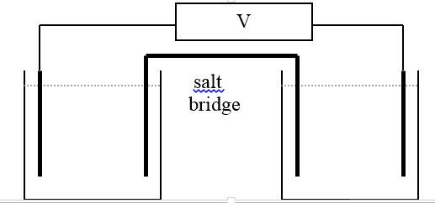

Oxidation half equation Reduction half-equation

__________________________ ________________________________

Overall equation ______________________________________________________

Theoretical cell voltage ____________________________
10 marks

Question 3 (5 marks)
Oxalic acid has a structure

Oxalic acid can be oxidised to carbon dioxide. An acidic solution is also produced.
a. i. Write a balanced half-equation for the oxidation of oxalic acid to carbon dioxide and acid. 1 mark

___________________________________________________________________________

ii. This half-equation is listed on the electrochemical series with a potential of -0.48 V
Write this half-equation as it will appear on the electrochemical series. 1 mark

__________________________________________________________________________

b. Oxalic acid can undergo a spontaneous redox reaction with iodine.
i. Write a balanced half-equation for the reduction of iodine. 1 mark

__________________________________________________________________________

ii. Write a balanced overall equation for the reaction between iodine and oxalic acid. 1 mark

___________________________________________________________________________

iii. What will the theoretical voltage of this cell be? ________________________________ 1 mark

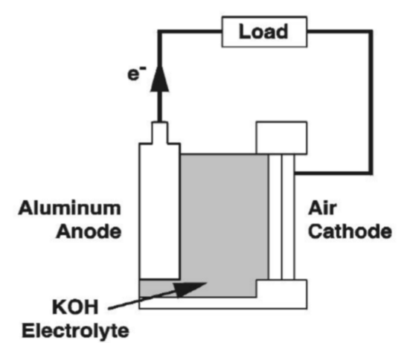
Question 4 (8 marks)
A cell that utilizes the reaction between aluminium and oxygen is commercially available. The cell has a voltage of 2.72 Volts.

The half-equation for the reaction of alumimium is

Al(s) + 3OH⁻(aq) Al(OH)₃(aq) + 3e⁻

a. i. What is the polarity of this electrode? 1 mark

___________________________________

ii. How will this electrode change with time as the cell discharges? 1 mark

_________________________________________________________________________

b. i. What is half-equation for the reaction of the oxygen? 1 mark

________________________________________________________________________

ii. Write a balanced equation for the overall reaction in this cell. 1 mark

________________________________________________________________________

c. 1.35 g of aluminium is consumed in this cell. What mass of oxygen will have been
consumed? 3 marks

__________________________________________________________________________

__________________________________________________________________________

__________________________________________________________________________

d. This cell is a primary cell but it can have a longer life than most cells if the aluminium
electrode is periodically replaced. Explain why this is done. 1 mark

__________________________________________________________________________

Question 5 (7 marks)
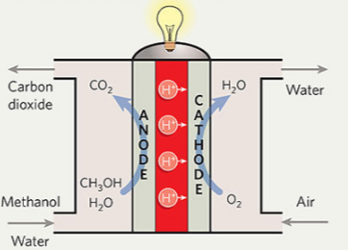
A fuel cell using methanol and oxygen is a common experimental cell. The cell operates in acidic conditions.

a. Use the template below to show the half equations and overall equation for this cell. 3 marks

Anode reaction : ________________________ Cathode reaction: ______________________

Overall equation: ____________________________________________________________

b. Determine the maximum amount of energy that could be formed from the reaction of 4.0 g of
methanol. 2 marks

___________________________________________________________________________

___________________________________________________________________________

c. The use of this cell on a large scale will have environmental impacts. List two likely impacts. 2 marks

___________________________________________________________________________

___________________________________________________________________________

END OF KEY TOPIC TEST

